* Your target's administrative and technical contacts

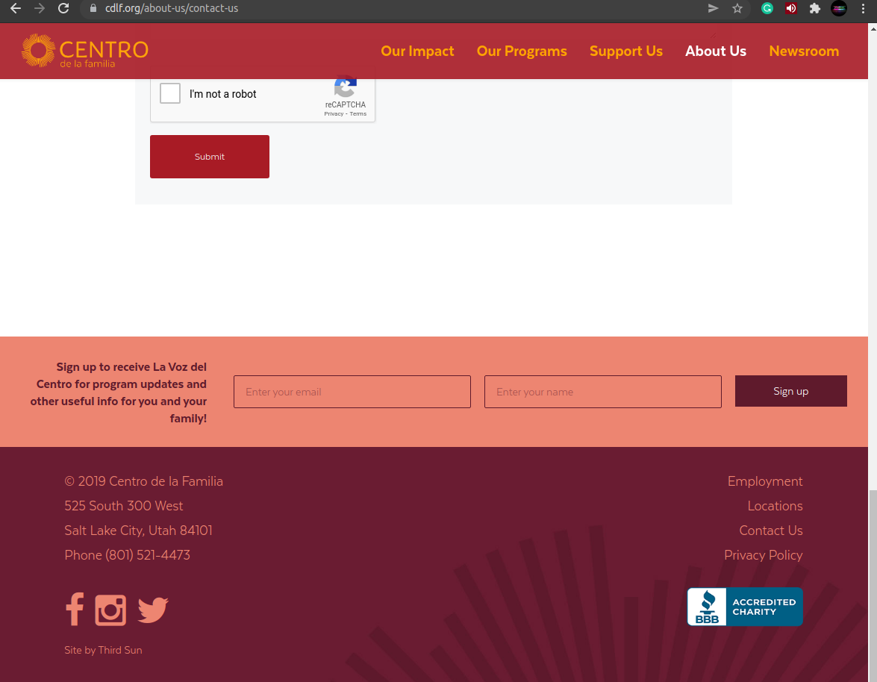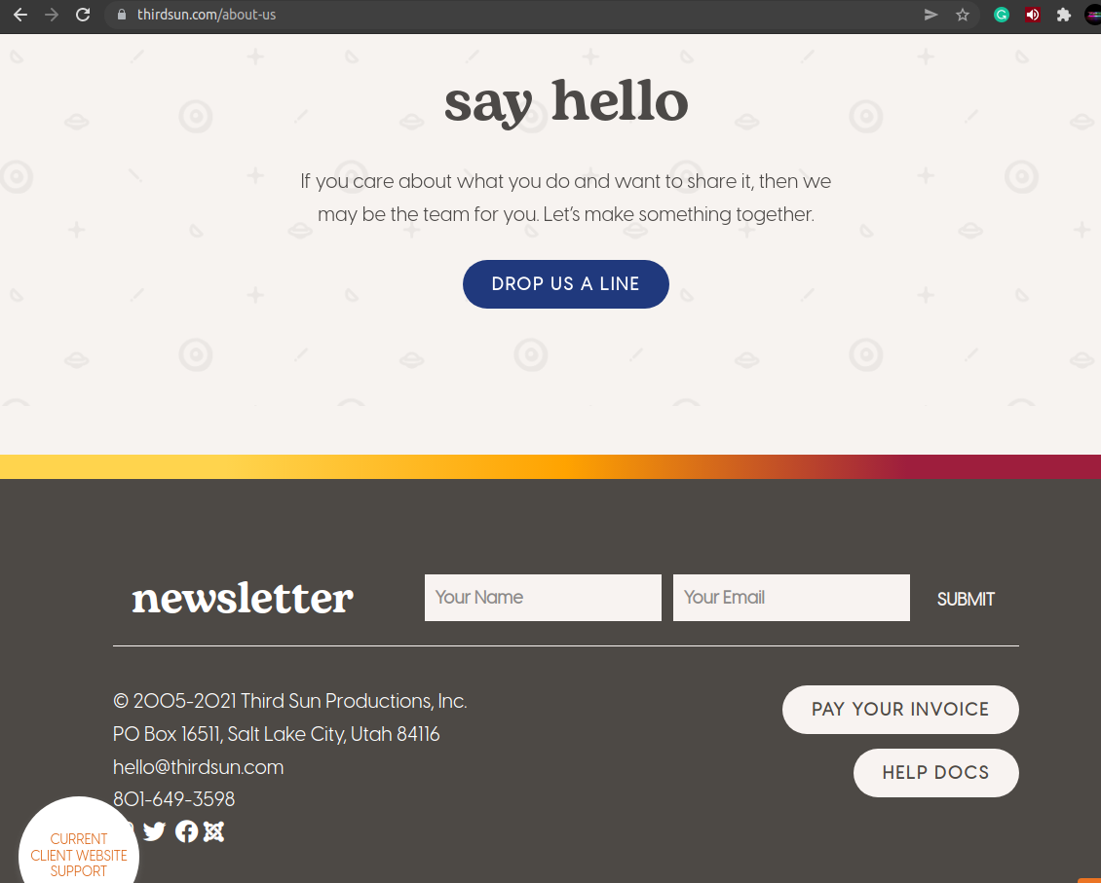

* Your target's main DNS IP address
  + IPv4 address 166.70.198.91
* 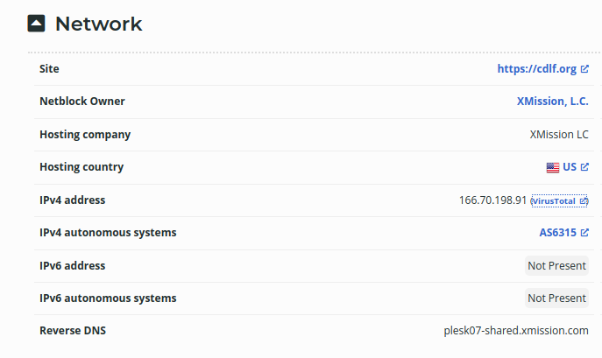
* Your target's probable web server technology

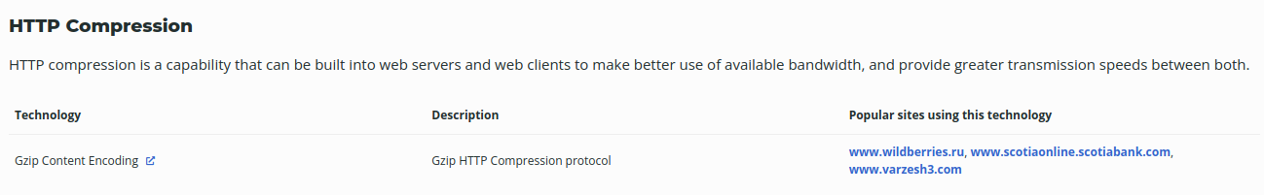

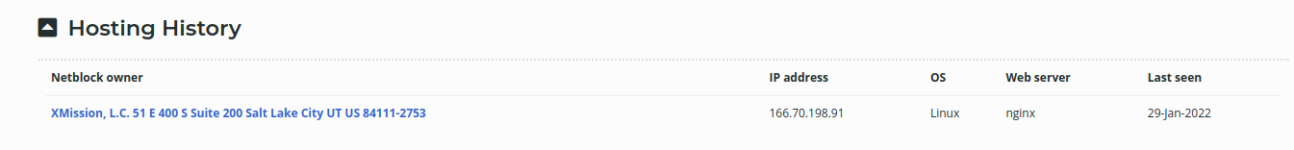

* The address of your target's probable A or AAAA server
* 
 